1.

Answer: Do… While loop.

Code:

#include <stdio.h>

int main()

{

int input, sum;

sum =0;

printf("Enter your number: ");

do{

scanf("%d", &input);

sum += input;

printf("\nYour sum is: %d\n", sum);

}while(input !=0 );

}

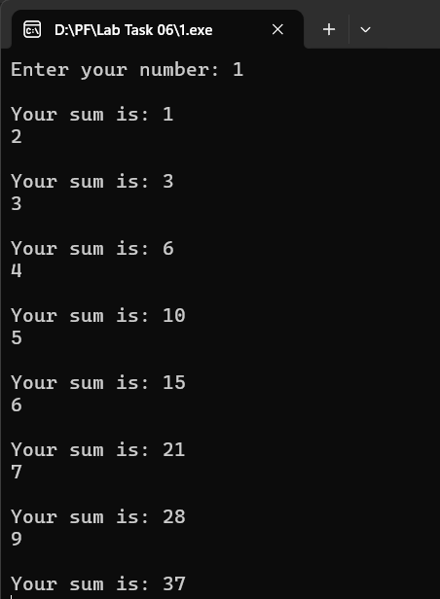

2.

#include <stdio.h>

int main()

{

int n, lcm;

scanf(" %d", &n);

lcm =1;

while(n>lcm && n !=1)

{

if (n%lcm == 0 && lcm !=1)

{

printf("Is not a prime number");

break;

}

//printf("%d\n", lcm);

lcm++;

}

if(lcm == n){

printf("Prime number");

}

}

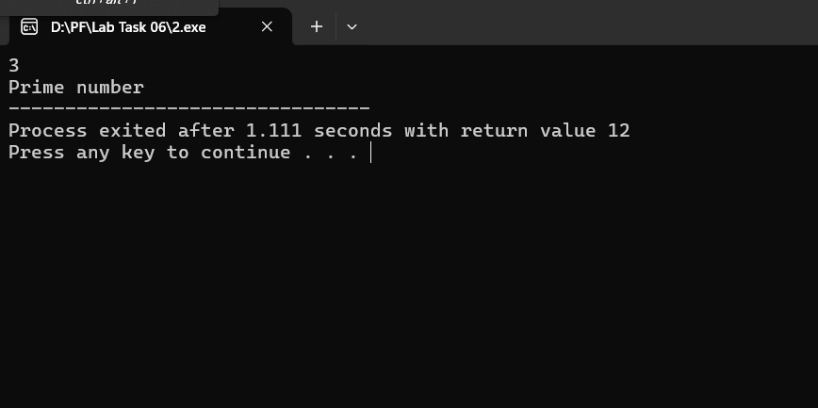

3.

#include<stdio.h>

int main()

{

int att, pin, pass;

att =0;

pin = 1234;

printf("Enter a 4 digit pin code\n");

do{

scanf("%d", &pass);

if(pin == pass && pass >999 && pass<10000)

{

printf("Password matched");

att++;

break;

}

else

{

printf("Password doesn't match\n");

att++;

}

}while(att <3);

if(pin !=pass && att ==3){

printf("System locked");

}

}

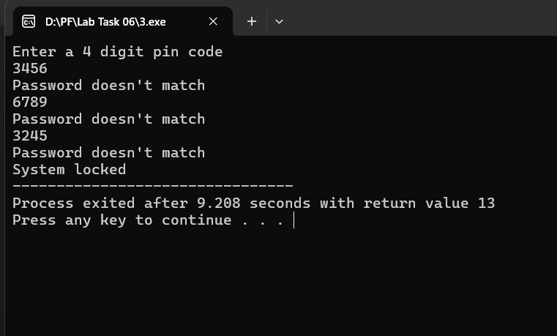

4.

#include<stdio.h>

int main()

{

int n, thisnum, temp, total;

scanf("%d", &n);

temp =n;

total =0;

while(temp>0)

{

thisnum = temp%10;

total += thisnum\*thisnum\*thisnum;

temp /=10;

}

if(total == n)

{

printf("Armstrong number");

}

else

{

printf("Not an armstrong number");

}

}

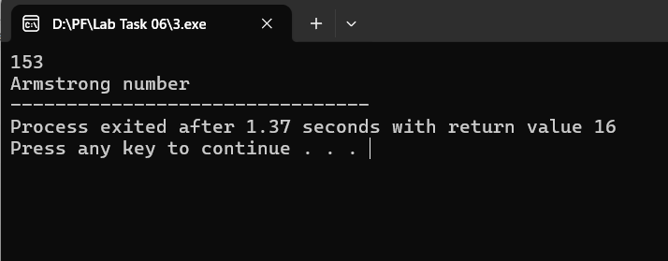

5.

#include<stdio.h>

int main()

{

int n;

scanf("%d", &n);

while(n>0)

{

printf("%d", n%10);

n/=10;

}

}

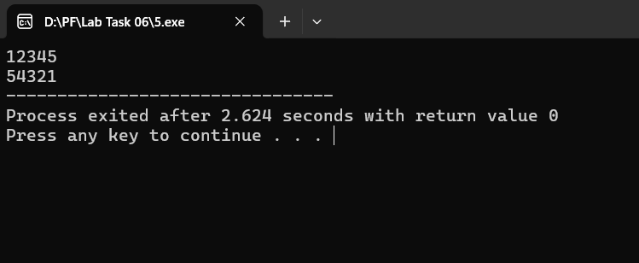

6.

#include <stdio.h>

int main() {

int fuel;

float cost;

const float rate = 1.50;

cost = 0;

do {

printf("Enter litres of fuel (or 0 to stop): ");

scanf("%d", &fuel);

if (fuel > 0) {

cost += fuel \* rate;

}

} while (fuel != 0);

printf("Total cost: $%.2f\n", cost);

}

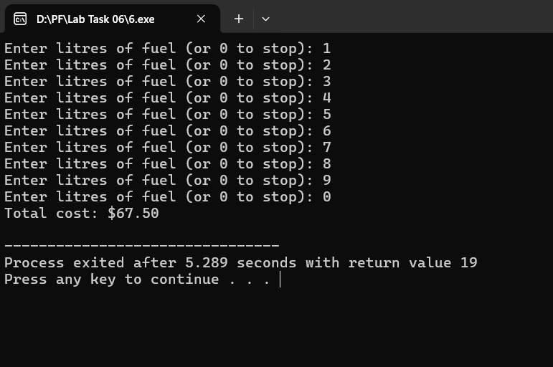

7.

#include <stdio.h>

int main()

{

int n, lcm;

scanf(" %d", &n);

lcm =1;

while(n>lcm && n !=1)

{

if (n%lcm == 0 && lcm !=1)

{

printf("Is not a prime number");

break;

}

//printf("%d\n", lcm);

lcm++;

}

int a,b,t;

a=0;

b=1;

t=0;

if(lcm == n){

t = a+b;

printf(" %d", a);

while(t<n)

{

printf(" %d", t);

t=a+b;

a=b;

b=t;

}

}

}

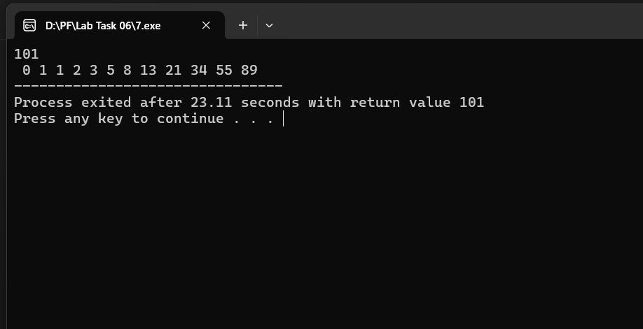

8.

#include<stdio.h>

int main()

{

int n, i, fact =1;

scanf("%d", &n);

if(n>=0)

{

for(i =n; i>0; i--)

{

fact\*= i;

}

printf("%d", fact);

}

else{

printf("Value should be positive");

}

}

